**CGG ASSIGNMENT 4**

Name: Kedar Kale

Roll No: 129

Block B1

Topic: Cohen-Sutherland Line Clipping Algorithm

Code:

#include<stdio.h>

#include<GL/glut.h>

#include<stdbool.h>

int TOP = 8;

int BOTTOM = 4;

int LEFT = 1;

int RIGHT = 2;

int INSIDE = 0;

int x_min = 100;

int x_max = 400;

int y_min = 100;

int y_max = 400;

int pt_x1, pt_x2, pt_y1, pt_y2;

void init2D(float r, float g, float b)

{

glClear(GL_COLOR_BUFFER_BIT);

glClearColor(r,g,b,0.0);

glMatrixMode (GL_PROJECTION);

gluOrtho2D (0.0, 500.0, 500.0, 0.0);

}

int cal_code(int x, int y)

{

int code = INSIDE;

if(x < x_min)

{

code = code | LEFT;

}

else if(x > x_max)

{

code = code | RIGHT;

}

else if(y < y_min)

{

code = code | BOTTOM;

}

else if(y > y_max)

{

code = code | TOP;

}

return code;

}

void clipping(int x1, int y1, int x2, int y2)

{

int code1 = cal_code(x1,y1);

int code2 = cal_code(x2,y2);

bool accept = false;

while(true)

{

if(code1 == 0 && code2 == 0)

{

accept = true;

break;

}

else if(code1 & code2)

{

break;

}

else

{

int code_out;

int x, y;

if(code1 != 0)

{

code_out = code1;

}

else

{

code_out = code2;

}

if(code_out & BOTTOM)

{

x = x1 + (x2 - x1) * (y_min - y1) / (y2 - y1);

y = y_min;

}

else if(code_out & TOP)

{

x = x1 + (x2 - x1) * (y_max - y1) / (y2 - y1);

y = y_max;

}

else if(code_out & RIGHT)

{

y = y1 + (y2 - y1) * (x_max - x1) / (x2 - x1);

x = x_max;

}

else if(code_out & LEFT)

{

y = y1 + (y2 - y1) * (x_min - x1) / (x2 - x1);

x = x_min;

}

if(code_out == code1)

{

x1 = x;

y1 = y;

code1 = cal_code(x1,y1);

}

else

{

x2 = x;

y2 = y;

code2 = cal_code(x2,y2);

}

}

}

if(accept)

{

glColor3f(0.0,1.0,0.0);

glBegin(GL_LINES);

glVertex2i(x1,y1);

glVertex2i(x2,y2);

glEnd();

glFlush();

}

}

void display()

{

clipping(pt_x1, pt_y1, pt_x2, pt_y2);

glBegin(GL_LINES);

glColor3f(0.0,1.0,0.0);

glVertex2i(x_min,y_min);

glVertex2i(x_min,y_max);

glVertex2i(x_max,y_min);

glVertex2i(x_max,y_max);

glVertex2i(x_min, y_max);

glVertex2i(x_max,y_max);

glVertex2i(x_min,y_min);

glVertex2i(x_max,y_min);

glEnd();

glFlush();

}

int main(int argc, char *argv[])

{

glutInit(&argc, argv);

scanf("%d", &pt_x1);

scanf("%d", &pt_y1);

scanf("%d", &pt_x2);

scanf("%d", &pt_y2);

glutInitDisplayMode(GLUT_SINGLE | GLUT_RGB);

glutCreateWindow("Clipping_Box");

glutInitWindowSize(1000,1000);

glutInitWindowPosition(0,0);

init2D(0.0,0.0,0.0);

glutDisplayFunc(display);

glutMainLoop();

}

Output:

1) Completely inside the box:

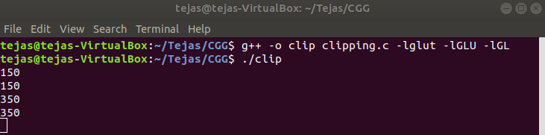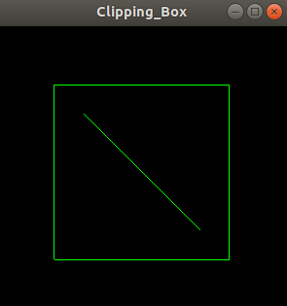

2) Paritally inside the box:

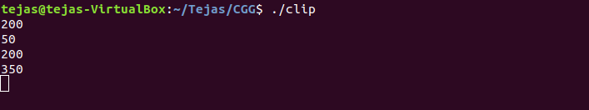

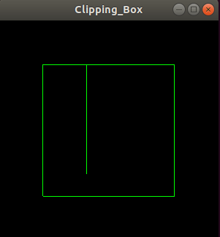

3) Completely outside the box:

